Unit 3 Exam Review
Formulas to Know:
MPC = ∆ consumer spending
∆ disposable income
MPS = 1-MPC
Consumer/government spending multiplier = 1/(1-MPC)
Consumption function =
C = A + MPC Y_{D}
Income and Expenditure
- Figure MPC and MPS.
See formulas and practice question #21 below.

- List and understand reasons for shifts in consumption graph. See question #22 below.

- List and understand reasons for shifts in investment demand curve. See question #23 below.
*Interest rates are reflected in the original line, but these factors shift it.

- Figure the multiplier and the resulting impact of autonomous changes in spending.
*Tax multiplier is always negative when dealing with impact of taxes on GDP.

- Figure and graph the consumption function.
See formula and practice question #22 below. (The graph on #22 is for the macroeconomy. For Micro, the axes are labeled C (consumption) and YD (disposable income). A is the vertical intercept.
Aggregate Supply & Aggregate Demand
- Define aggregate supply and aggregate demand.
Aggregate supply – The total amount of goods and services that all firms in a country are willing to produce at each price level.
Aggregate demand – The total quantity of all goods and services demanded at each price level.

- List and understand reasons for shifts of the AS and AD curves. See practice question #29.

- Identify results of AD and AS shifts on: See practice question #29.
  - Employment/unemployment
Negative AD or AS shift results in lower employment, positive AD or AS shift results in higher employment
  - Price level
Negative AD shift results in lower price level, positive AD shift results in higher price level
Negative AS shift results in higher price level, positive AS shift results in lower price level
  - Real GDP
Negative AD or AS shift results in lower Real GDP, positive AD or AS shift results in higher Real GDP

- Explain why the AD curve is downward sloping.

- Explain why the SRAS and LRAS curves are sloped as they are.

- Define sticky wages and relationship with aggregate supply.
The AD-AS Model
- Determine the impact of market conditions on SRAS, LRAS and the PPC.
See #7 above and practice question #25.

- Identify and graph recessionary and inflationary gaps.
Recessionary Gap Inflationary gap
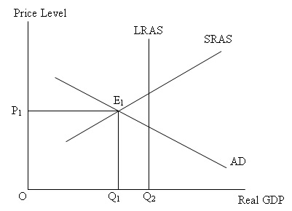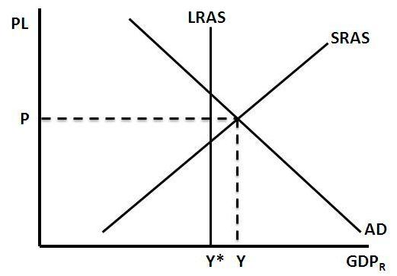
- Define Y_{P}.

- Define stagflation and identify its effects on the economy. See practice question #26.
Stagflation – rising prices and falling output (as well as rising unemployment). Result from leftward shift of SRAS curve (reduction in supply). Difficult to deal through policy because any attempt to deal with either inflation or unemployment worsens the other issue.

Practice Questions
- Complete this chart.
Income | Expenditures | MPC | MPS
$20,000 | $11,000 | N/A | N/A
$40,000 | $25,000 | 0.7 | 0.3
$60,000 | $35,000 | 0.5 | 0.5
$80,000 | $41,000 | 0.3 | 0.7

- Determine the multiplier and the net effect of the following autonomous changes in spending:
  - An influx of $100 billion in government spending when the marginal propensity to consume is 0.75.
Multiplier = 1/1-MPC or 1/1-.75 = 1/.25 = 4
Net effect of $100 billion spending is $100 billion 4 = $400 billion

  - An influx of $250 billion in business investment when the marginal propensity to consume is 0.5.
Multiplier = 1/1-MPC or 1/1-.5 = 1/.5 = 2
Net effect of $250 billion spending is $250 billion 2 = $500 billion

  - An influx of $180 billion in export sales revenue when the marginal propensity to consume is 0.8.
Multiplier = 1/1-MPC or 1/1-.8 = 1/.2 = 5
Net effect of $180 billion spending is $180 billion 5 = $900 billion
- If consumer spending increased by $25 billion, resulting as an equilibrium output increasing by $75 billion. What is the value of the MPC? K=3 ($75 billion/$25 billion), 3=1/MPS, MPS=.33, MPC=.67 26.

- Suppose an individual’s autonomous consumption is $15,000, his disposable income is $50,000 and his marginal propensity to consume is .75. What is the individual’s consumption spending? CF= $15,000 + ($50,000 x .75), CF = $52,500

- Falling inventories, also known as __Negative Unplanned Inventory Investment___, occurs when sales are (higher/lower) than expected. This reflects a (strengthening/weakening) economy.

- Rising inventories, also known as ___Positive Unplanned Inventory Investment___, occurs when sales are (higher/lower) than expected. This reflects a (strengthening/weakening) economy.

- How would each of the following impact the level of planned investment spending?
 |  | Effect on investment spending |  | Effect on investment spending
Interest rates | High | Decrease | Low | Increase
Expected real GDP | High | Increase | Low | Decrease
Production capacity | High | Decrease | Low | Increase
Rate of return | High | Increase | Low | Decrease

- A change in __Price Level__ results in movement along the AD/AS curves.

- Potential Output is equal to $500 billion and current output is $400 billion. What is the output gap? ($400-$500)/$500 x 100 = -20%

- Which event, a demand shock or supply shock, is more difficult for the government to alter through economic policies? Why? Negative Supply Shock. Causes high inflation and high unemployment. Government cannot directly influence SRAS, only AD curve. If you fix one problem by shifting AD, you hurt the other problem more.

- Create a correctly labeled graph of an economy at macroeconomic equilibrium. 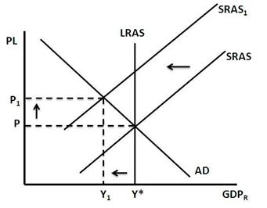

  - Draw and label a new SRAS curve (SRAS1 ) representing a shift into stagflation.
  - Label the new price level and output at SRAS1 .
  - Why does this shift result in the greatest hardships for the economy?
  - d. See #15 above.
- What is a weakness of fiscal policy? What might happen as a result from this weakness? Time lags: In the form of Recognition, Decision, and Implementation lags. Government may end up doing more harm than good as a result of these lags.

- Assume that the marginal propensity to consume is 0.8, and potential output is $800 billion. If current GDP is $850 billion, a policy (increasing/decreasing) taxes by __$12.5 billion __ would bring the economy to potential output. KT =- .8/(1-.8) = -4, $50 billion/-4 = -$12.5 billion in real GDP

- Assume that the marginal propensity to consume is 0.8, and potential output is $800 billion. If current GDP is $850 billion, a policy (increasing/decreasing) government spending by __$10 billion __ would bring the economy to potential output. K=1/.2=5, $50 billion/5 = $10 billion

- In Wonderland’s current economy households save 50% of their income. If the government lowers its transfers by $200 billion, what will real GDP be? MPS = 0.5, MPC = 0.5; M = 1/.5 = 2; Disposable income is decreased by $200 billion (note: 50% of this will be leaked into savings.)We will have to multiply the multiplier by $100 billion (the 50% of disposable income that is consumed.) $100 billion x 2 = a fall in $200 billion OR You could use the KT=.5/1-.5=1; 1 x $200 =a fall in $200 billion

- The current MPC is 0.8. The economy is experiencing a recessionary gap. Apply the multiplier effect and your knowledge of fiscal policy options to determine the net effect of each of the following, and determine which of the following options is likely to have the greatest impact.
- A $60 billion increase in government transfers
$60 billion flows into the hands of consumers, who have a MPC of 0.8, so $60 billion 0.8, or $48 billion actually goes into circulation. The multiplier effect applies to that $48 billion. The multiplier is 1/(1-MPC), or 1/(1-.8) = 1/.2 = 5.
$48 billion 5 = $240 billion, so this is the net effect on Real GDP of $60 billion increase in government transfers
- A $50 billion decrease in taxes
The tax cut means that $50 billion in additional disposable income is in the hands of consumers, who have a MPC of 0.8, so $50 billion 0.8, or $40 billion actually goes into circulation. The multiplier effect applies to that $40 billion, and we established in part (a) that the multiplier is 5 for a MPC of 0.8.
$40 billion 5 = $200 billion, so this is the net effect on Real GDP of $50 billion decrease in taxes

- A $50 billion increase in government spending
This $50 billion in spending has a direct effect on aggregate demand, so this entire amount goes into circulation. Therefore, the whole $50 billion is subject to the multiplier effect.
$50 billion 5 = $250 billion, so this is the net effect on Real GDP of $50 billion increase in government spending – and this is the option likely to have the greatest effect

- Assuming each of the following were significant in magnitude and long-lasting, what would be the effect of:
 | Effect on SRAS | Effect on LRAS | Effect on PPC
Tax increase to offset government spending | No change (negative shock to DEMAND) | No change | No change
Revolutionary successes in research and development | Increase | Increase | Increase
Implementation of a better education system | No change (has no immediate effect) | Increase | Increase
Unions organized to achieve higher wages | Decrease | No change (as wages are flexible, not sticky, in the long run) | No change (as PPC only moves when LRAS does)

- Determine the likely effect of each of the following on AD –or – SRAS (only one shift, negative or positive) and the resulting impacts on the economy.
 | Effect on AD | Effect on SRAS | Impact on Price Level | Impact on Real GDP | Impact on Unemployment
A decrease in wealth | Decrease | No change | Decrease | Decrease | Increase
Pessimistic consumer expectations | Decrease | No change | Decrease | Decrease | Increase
A decrease in stock (inventory) | No change | Increase | Decrease | Increase | Decrease
Contractionary fiscal policy | Decrease | No change | Decrease | Decrease | Increase
Expansionary fiscal policy | Increase | No change | Increase | Increase | Decrease
A decrease in the quantity of money | Decrease | No change | Decrease | Decrease | Increase
An decrease in the cost of oil | No change | Increase | Decrease | Increase | Decrease
An increase in minimum wage | Increase | No change (initially, though this would decrease pretty quickly…) | Increase | Increase | Decrease
A significant improvement in technology | No change | Increase | Decrease | Increase | Decrease

